**8 SCIENCE CHEMISTRY INVESTIGATION 2016**

OBSERVING CHEMICAL REACTIONS

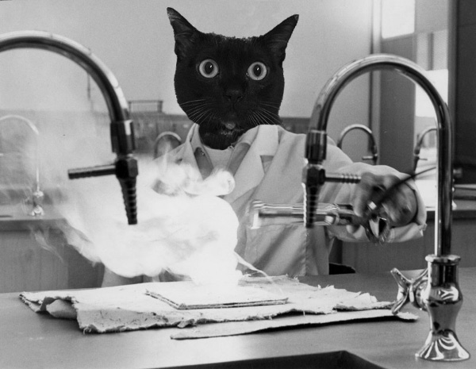

Name:__________________ Teacher:__________________

Form:__________________ Due date:_________________

**Plagiarism**

You must write in your own words, not copy sentences word for word from another student or another source.

Plagiarising = instant zero on assignment and you will have to re-do it.

**Assessment policy**

Give me a sick note/legitimate reason from parent BEFORE due date = new negotiated due date.

One day late = -20% taken off mark

Two days late = -40% taken off mark

Three days late = mark of zero given, students are required to attend a detention and are still required to submit the assignment.

**If you are not at school the day this assignment is due, please email this booklet to me by 4pm on the due date.**

**____________________@aranmore.wa.edu.au**

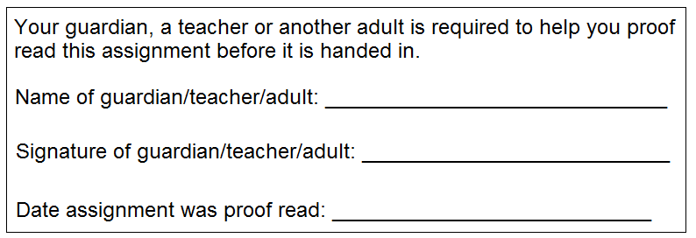

**Introduction**

Every chemical reaction is accompanied by a change in temperature. Sometimes the change is barely noticeable and other times it is extreme. Sometimes the temperature goes up and other times it goes down.

**Aim**

To observe the chemical changes in two chemical reactions and see whether they are exothermic or endothermic reactions.

In your own words, explain what the term exothermic means. (1 mark)

_______________________________________________________________________________________________

_______________________________________________________________________________________________

_______________________________________________________________________________________________

In your own words, explain what the term endothermic means. (1 mark)

_______________________________________________________________________________________________

_______________________________________________________________________________________________

_______________________________________________________________________________________________

*This investigation involves two different reactions. When you complete the variables and hypothesis below, they are referring to both reactions together as one investigation.*

**Independent variable**  (1 mark)

_______________________________________________________________________________________________

**Dependent variable**  (1 mark)

_______________________________________________________________________________________________

**One controlled variable** (1 mark)

_______________________________________________________________________________________________

**Hypothesis** (do not use ‘I’, ‘we’ or other personal language) (2 marks)

_______________________________________________________________________________________________

_______________________________________________________________________________________________

_______________________________________________________________________________________________

_______________________________________________________________________________________________

_______________________________________________________________________________________________

_______________________________________________________________________________________________

**Experiment One**

**Materials:**

⬩ Teaspoon ⬩ Tablespoon

⬩ 2 tablespoons 3% hydrogen peroxide ⬩ 1 teaspoon yeast

⬩ 1 x plastic cup ⬩ Thermometer

⬩ Stopwatch

**Method**

1. Put 2 tablespoons of 3% hydrogen peroxide into a plastic cup.

2. Place a thermometer into the cup and hold the thermometer and cup so that they do not fall over.

3. Read the temperature and record the time in the results table for zero seconds.

4. Tip 1 teaspoon of yeast into the cup.

5. Gently swirl the cup while one group member calls out the time every 10 seconds.

6. When each 10 seconds is called, the other group member calls out the temperature and the third group member records the temperature in the table.

**Results table** (show the results taken from experiment, in pencil and using a ruler) (3 marks)

1. Using observations, explain how you can tell that the reaction was a chemical reaction and not a physical reaction.

(2 marks)

_______________________________________________________________________________

_______________________________________________________________________________

_______________________________________________________________________________

_______________________________________________________________________________

2a. Was this chemical reaction an endothermic reaction or an exothermic reaction? (1 mark)

_______________________________________________________________

b. Explain the reason for your answer to by relating to your results. (2 marks)

_______________________________________________________________________________

_______________________________________________________________________________

_______________________________________________________________________________

_______________________________________________________________________________

_______________________________________________________________________________

_______________________________________________________________________________

**Experiment Two**

**Materials:**

⬩ Teaspoon ⬩ Tablespoon

⬩ 2 tablespoons vinegar ⬩ Baking soda

⬩ 1 x plastic cup ⬩ Stopwatch

⬩ Thermometer

**Method**

1. Put 2 tablespoons of vinegar into a cup.

2. Place a thermometer into the cup and hold the thermometer and cup so that they do not fall over.

3. Read the temperature and record the time in the results table for zero seconds.

4. Tip 1 teaspoon of baking soda into the cup.

5. Gently swirl the cup while one group member calls out the time every 3 seconds.

6. When each 3 seconds is called, the other group member calls out the temperature and the third group member records the temperature in the table.

**Results table** (show the results taken from experiment, in pencil and using a ruler) (3 marks)

1. Using observations, explain how you can tell that the reaction was a chemical reaction and not a physical reaction.

(2 marks)

_______________________________________________________________________________

_______________________________________________________________________________

_______________________________________________________________________________

_______________________________________________________________________________

2a. Was this chemical reaction an endothermic reaction or an exothermic reaction? (1 mark)

_______________________________________________________________

b. Explain the reason for your answer to by relating to your results. (2 marks)

_______________________________________________________________________________

_______________________________________________________________________________

_______________________________________________________________________________

_______________________________________________________________________________

_______________________________________________________________________________

_______________________________________________________________________________

**Graph** (show the results in a graph using a sharp lead pencil and ruler) (6 marks)

This graph is to show **both reactions**. Use a different line for each reaction. Make a legend to show which line represents which reaction.



**Discussion** (describe one mistake or error that occurred, explain how it affected the results and how it could be avoided next time)

Remember that a mistake can be avoided with care and an error is a small change to measurement that cannot be avoided. (3 marks)

_______________________________________________________________________________

_______________________________________________________________________________

_______________________________________________________________________________

_______________________________________________________________________________

_______________________________________________________________________________

_______________________________________________________________________________

_______________________________________________________________________________

_______________________________________________________________________________

_______________________________________________________________________________

_______________________________________________________________________________

_______________________________________________________________________________

**Conclusion** (state the results and whether the hypothesis was supported or not supported) (2 marks)

_______________________________________________________________________________

_______________________________________________________________________________

_______________________________________________________________________________

_______________________________________________________________________________

_______________________________________________________________________________

_______________________________________________________________________________

Assignment is neatly written or typed. (1 mark)

Correct spelling and grammar. (1 mark)

Scientific language is used. (1 mark)

/37 Mark as percentage: %

Teacher comment: on Seqta